Summary and Reflection Report
Shawn Carrier
Southern New Hampshire University
CS 320 Software Test Automation and QA
Neil Kalinowski
20 February 2022

Unit Testing Approach and Experience with JUnit Testing
When writing the unit tests for each portion of the project, I really tried to keep the requirements in mind. For the task service I missed a few requirements, but ultimately went back and rewrote the code and unit tests for that milestone twice. The second time I rewrote it I think I got it all covered. Looking at the code, the ID, task name, and description all had to be greater than a null field while also falling below the thresholds set of ten, twenty, and fifty, respectively. Here I set up all my test parameters for valid and invalid data:

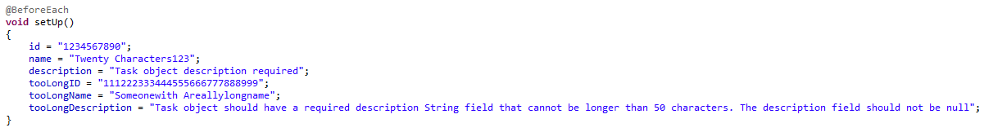

Using those parameters, testing for validity was straightforward. Not shown are the tests setting the fields to the valid data, but after that using pointers to reset the fields to the ‘toolong’ parameters, and subsequently setting them to a null value allowed for further coverage of use cases and validating the data entered. Here are two examples of the tests used for data that exceeded the limit as well as a null value.
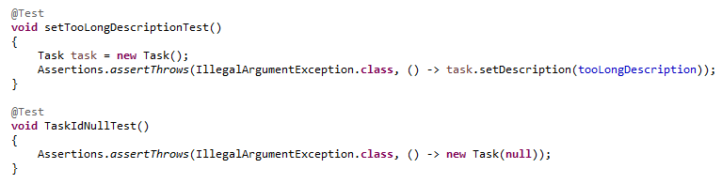
I found that setting the field values to null ensured coverage of that use case easier than looking for no user input, since a blank field is still a value regardless of content. Similarly, setting tests up in that manner kept them less wordy, and easier to parse and adjust. Even using a similar style of test writing for the Appointment Service served a similar purpose for compactness and coverage, as seen here:

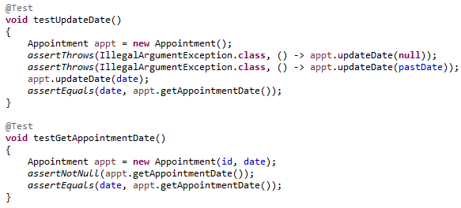

Ensuring that my code was technically sound involved utilizing feedback from Professor Kalinowski, as well as re-writing code I knew I was not happy with. This gave further experience in writing unit tests as well as cleaning up the general code for ease of access and readability. The only code I did not fully rewrite was the Contact Service section as I did not have the time while moving forward with other sections. As seen in the code screenshot below, the tests for Contact Service do what they need to but they are lengthy, and less clear and sophisticated as the tests for Task Service and Appointment Service. Going back to those would probably require a full re-do of both the code and the tests.
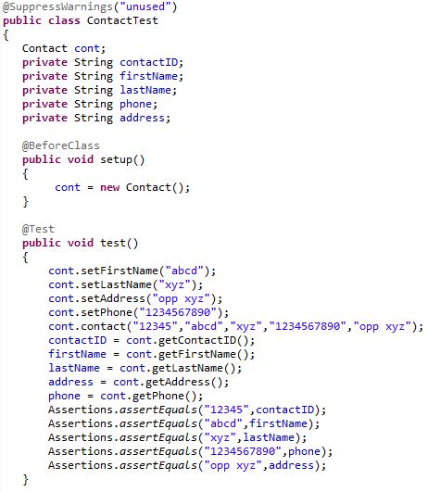
Testing Techniques and Overall Mindset
In module five, I discussed my approach to the techniques I use and which ones I did not. For all three portions of the project, I kept to the same philosophy when writing my unit tests. When creating the unit tests, the technique I lean towards is black and white box categories. These are probably the easiest to employ due to the format of the project and specs. Black box techniques use partitioning to test for both valid and invalid input. Over the course of the term, structure-based testing was valued as a primary option for testing statement coverage, but also can include path and branch coverage as necessary.
The biggest testing technique not used was experience-based testing. Lack of professional development experience limits knowledge of potential error sites. Error guessing and exploration testing compile most of experience-based testing. Error guessing determines which tests would be best to use to analyze code, and exploration testing is used primarily to test areas of our code that lack specifications. Exploratory testing feels almost irrelevant since we have a clear list of requirements for the milestones.
All the techniques mentioned have unique and specific applications. White box techniques can be used in a situation where the development team understands the desired outcome of the product being tested, whereas black box techniques can be applied to areas where the code has clearly defined functionality or can be used for outsourced testing. Previous experience in the development life cycle has had me working with an outsourced development and testing team on an access control system and associated databases. I feel like this is the best use case scenario for black box and white box testing due to the nature of database restrictions (i.e., character limits, barcode storage restrictions and requirements, etc.). The other techniques mentioned were experience-based testing which encompasses error guessing and exploratory testing. These techniques could be used when broad tests and testing techniques cannot be easily implemented, or when we have missing requirements. Regarding databases, if one of the requirements, say name, had not had a length maximum then I could see an experience-based limitation test being used.
When reviewing code, it’s important to test knowledge of the core concepts, such as creating operators, constructors, loops, methods, etc., and the ability to progress past the basic applications of those concepts. Concerns that arise when testing code could involve any lack of knowledge of the core concepts and how to run tests for validity. Additionally, it is important to have clean code written to reduce resources used while running the code and tests. Similarly, having cleaner code can reduce time spent and costs accrued over the course of the project. Features should not be developed without understanding because they challenge the functionality of a system long term. For example, implementing two types of bio-identification for verification purposes could cause delays in a system’s speed and/or functionality.
Working through this project required a positive mindset. Typically, I get very frustrated when something does not work innately, despite knowing that code can be trial and error when bug fixing or troubleshooting problems. As mentioned earlier I re-wrote both the Task and Appointment Service applications due to not being satisfied with them. Was it frustrating? Yes. Was it worth it? Also, yes. It allowed me to keep an open mind to different ways to solve the problem, as well as allowed me to stop looking at something that was going to frustrate me and cause me to lose that positive mindset. It also allowed me to fix mistakes and research why my previous attempts were inefficient when looking at feedback received.
While reviewing my code, I was able to find a few instances of bias in the way I was constructing tests. As mentioned previously, replacing/writing tests that looks for a null value rather than a blank field allowed for seeing that different people could either skip entering data or start and not finish or remove it. Annotating the code before review helped me scan through sections I was not sure about quicker by being able to read what something is coded to do.
Over the course of the term, I was able to eliminate errors effectively through the practices mentioned above. Appreciating code complexity and interrelations can help simplify challenges experienced during review and testing by presenting various options to tackle them. Discipline is vital during the software development process. It allows the developer to appreciate challenges, code complexity, and inter-module relations. I plan to avoid technical debt by following sound and strong coding practices, as well as maintaining a high percentage of code coverage.

